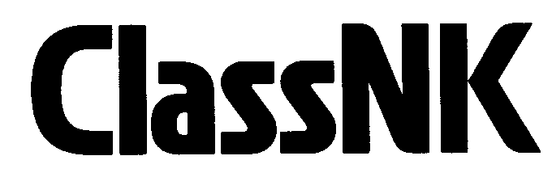 Notification for Change of Ship Management

To:　**NIPPON KAIJI KYOKAI Classification Department**

(Fax: +81-43-294-5449, E-mail: cldjt@classnk.or.jp)

From:

|  |  |  |  |  |  |  |  |
| --- | --- | --- | --- | --- | --- | --- | --- |
| Name of Company | | : |  | | | | |
| Contact Person / Title | | : |  | | | | |
| Tel.: |  | | | Fax. : |  | e-mail: |  |

Please be informed that ship management of the below mentioned vessel(s) have been changed to the new manager as followings:

|  |  |  |
| --- | --- | --- |
| Name of vessel(s) | Classification No. | Date of Manager Change |
|  |  |  |
|  |  |  |
|  |  |  |
|  |  |  |
|  |  |  |
|  |  |  |
|  |  |  |

*\* If there is not enough space to write names of all vessels, please attach separate sheet.*

Detail of New Ship Management Company

|  |  |  |  |  |  |  |  |
| --- | --- | --- | --- | --- | --- | --- | --- |
| Name of Company | | : |  | | | | |
| Contact Person | | : |  | | | | |
| Contact Address: | | : |  | | | | |
| Tel.: |  | | | Fax. : |  | e-mail: |  |